Jenkins 04 (Task -02)
Title: Setup a Jenkins CICD pipeline using Declarative pipeline using feature-1.1 branch. https://github.com/betawins/sabear_simplecutomerapp/tree/feature-1.1
stages:
Git Clone
SonarQube Integration
Maven Compilation
Nexus Artifactory
Slack Notification
Deploy On tomcat
objective:
To design and implement an end-to-end Jenkins CI/CD pipeline using a Declarative Pipeline that performs the following:
Clone source code from the feature-1.1 branch
Perform static code analysis using SonarQube
Compile and package the application using Maven
Upload build artifacts to Nexus Repository
Send build status notifications to Slack
Deploy the application on Apache Tomcat
prerequisite:
Jenkins server (Linux-based preferred)
Apache Tomcat server
Nexus Repository Manager
SonarQube server
Slack workspace with Incoming Webhook
step by step process:
logged into Jenkins dashboard—new item—Jenkins 04_02—select pipeline and click on save
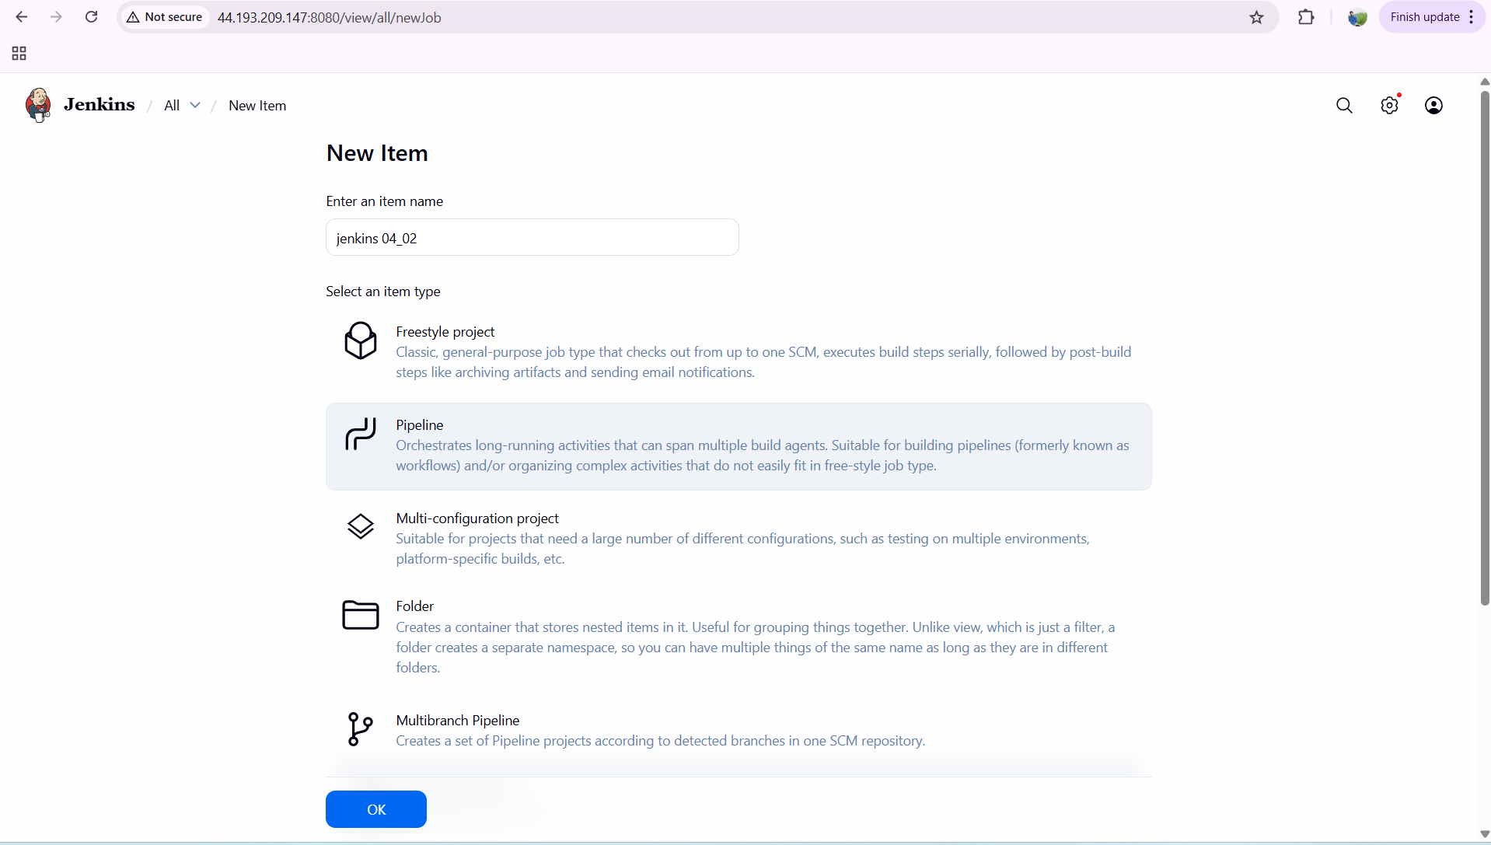
now after creating…enter the description as Declarative pipeline
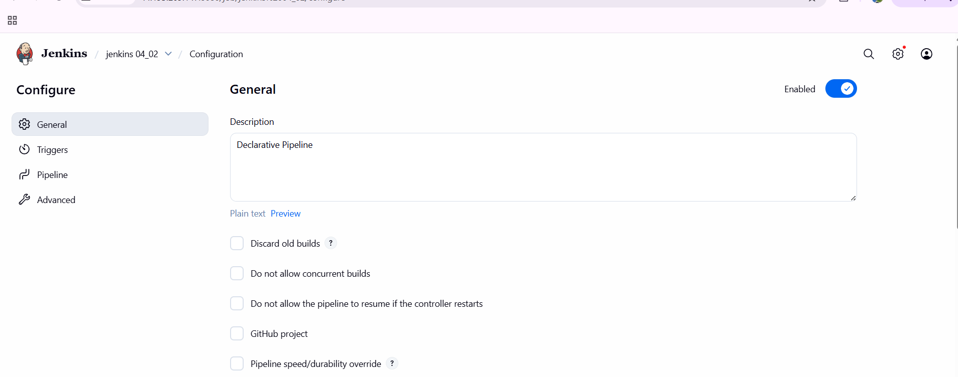

Git clone stage
Configured pipeline to use feature-1.1 branch.
GitHub repository used:
https://github.com/betawins/sabear_simplecutomerapp
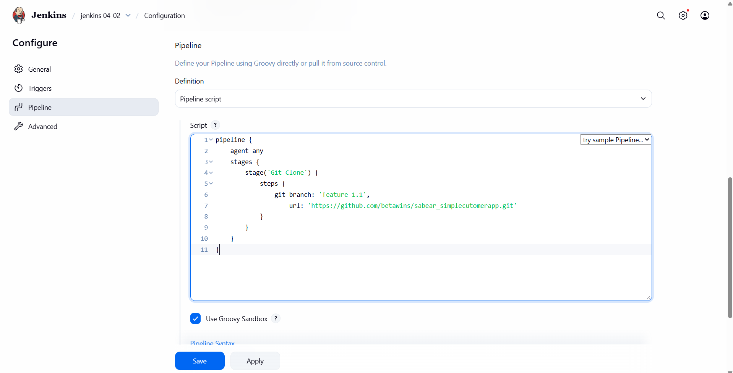
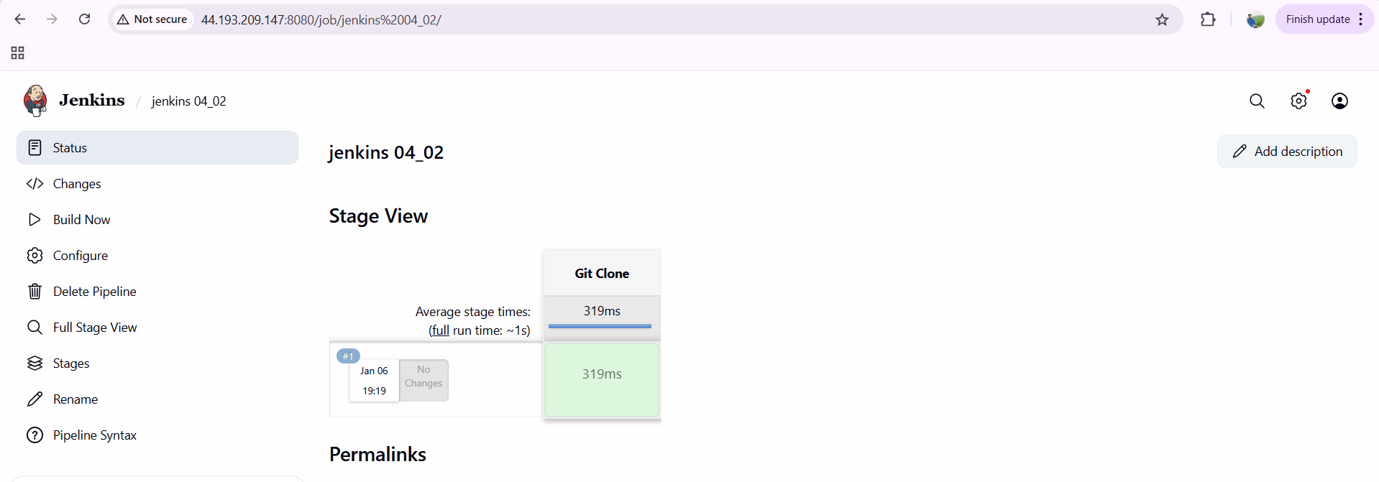
SonarQube Integration
to check the quality of the code which we have used
Configured SonarQube server in Jenkins Global Tool Configuration.
Used with Sonar Qube Env('SonarQube-server') in pipeline.
Executed Sonar Scanner with
Project Key: sabear-simplecustomerapp
Project Name: SimpleCustomerApp
SonarQube analysis completed successfully.
status shown as Passed in SonarQube dashboard.
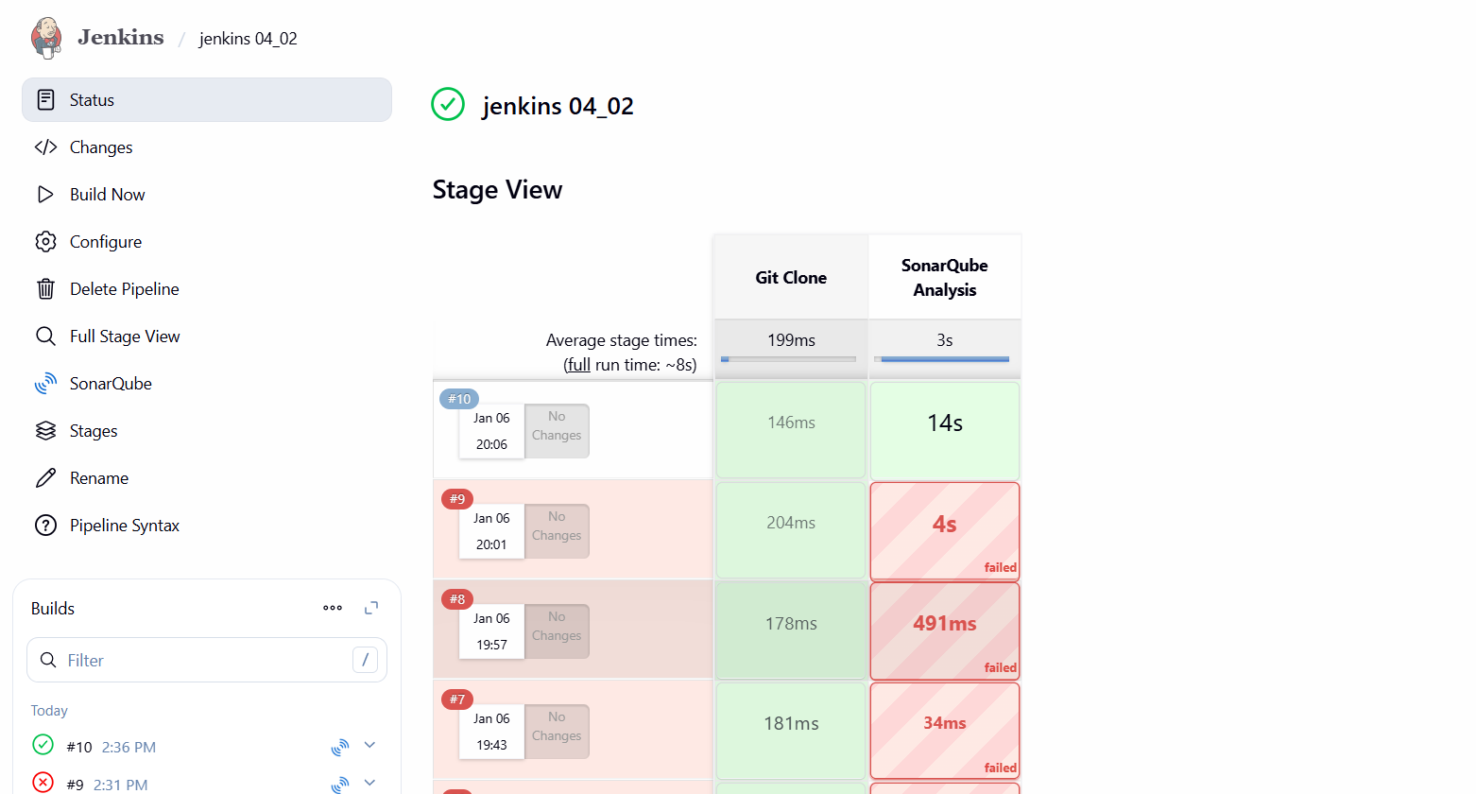
verify in console output
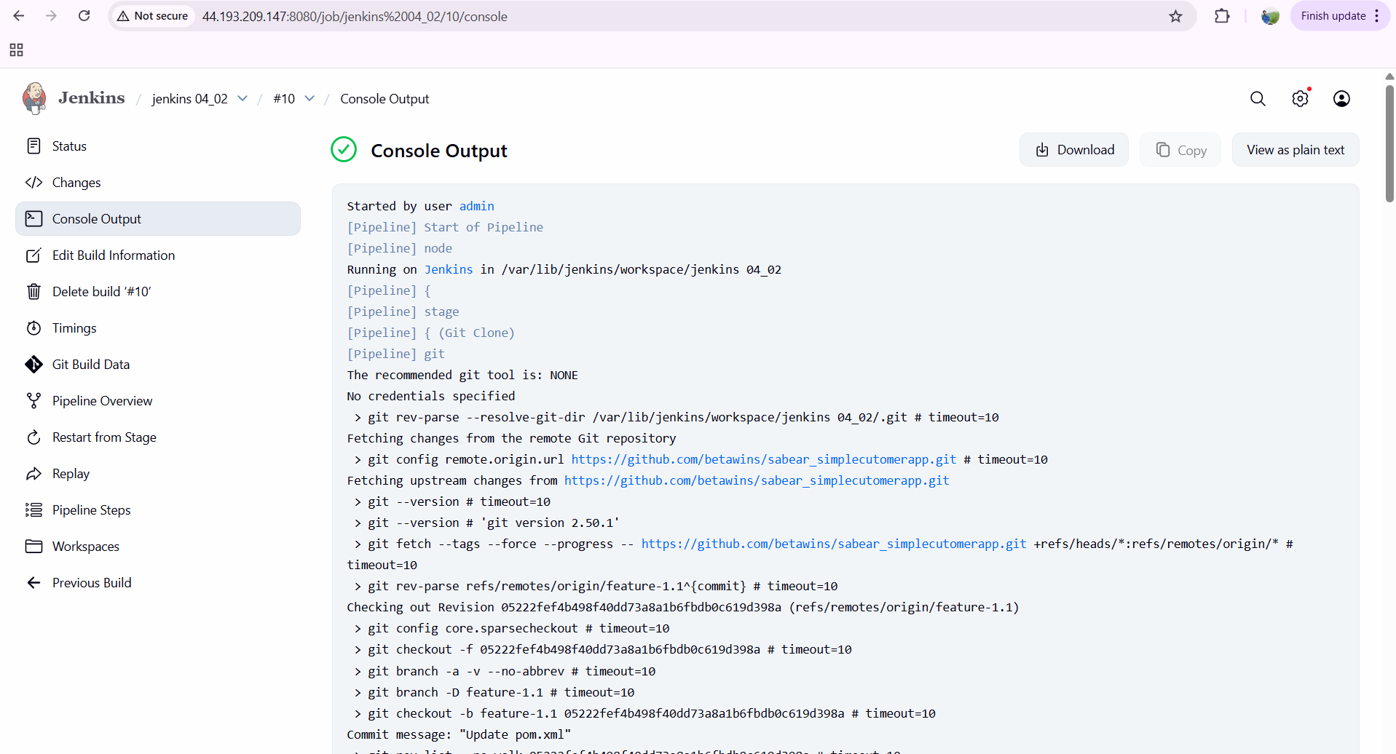
issues faced:
wrong sonar scanner path
given sonar exclusions wrong
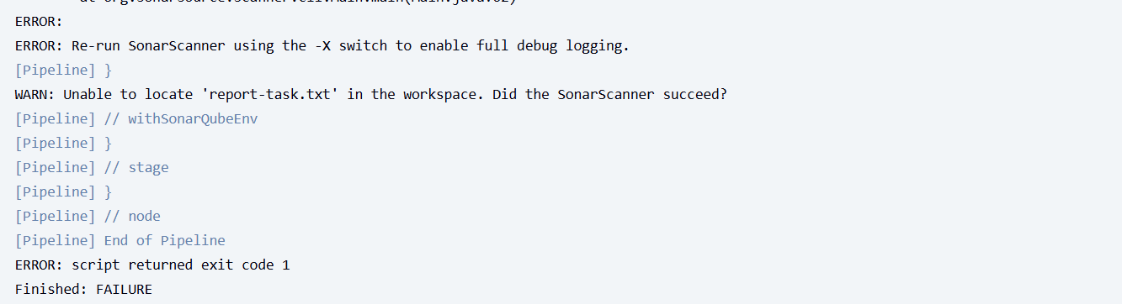
Maven Compilation Stage
To compile, test, and package the application
Configured Maven installation path in pipeline environment.
mvn clean package
click on build now—build success
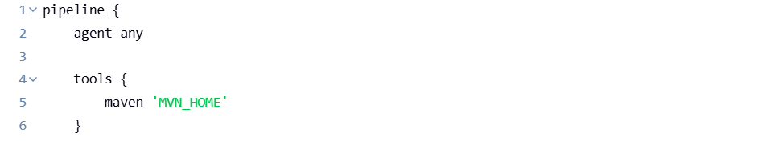
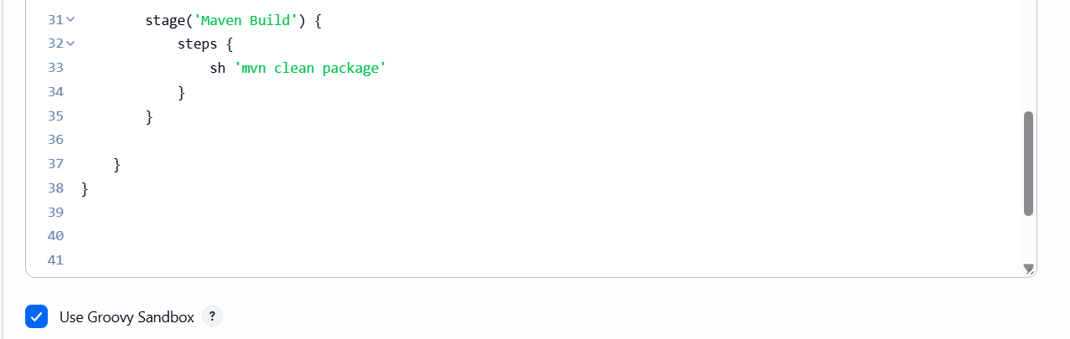
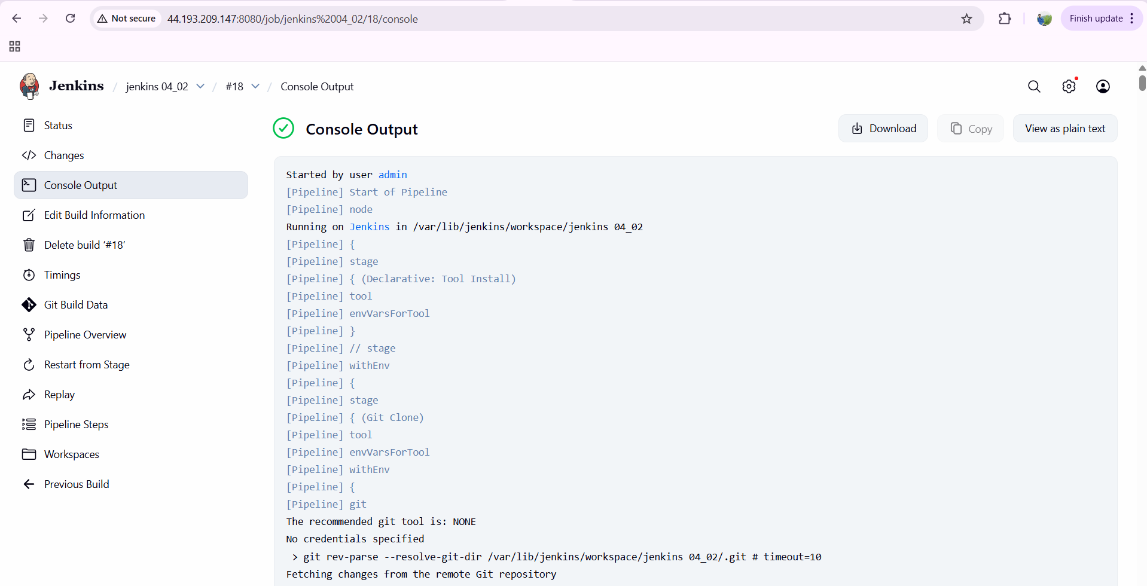
issues faced:
given unnecessary braces {}
not given tool as MVN_HOME and started executed
later given name and started build now
Nexus Artifactory Upload Stage
Configured Nexus Repository Manager (Nexus 3).
Used nexus Artifact Uploader plugin in pipeline.
Nexus details used:
Repository: snapshot repository
Group ID: com.javatpoint
Artifact ID: SimpleCustomerApp
Version: ${BUILD_NUMBER}-SNAPSHOT
Artifact Type: war
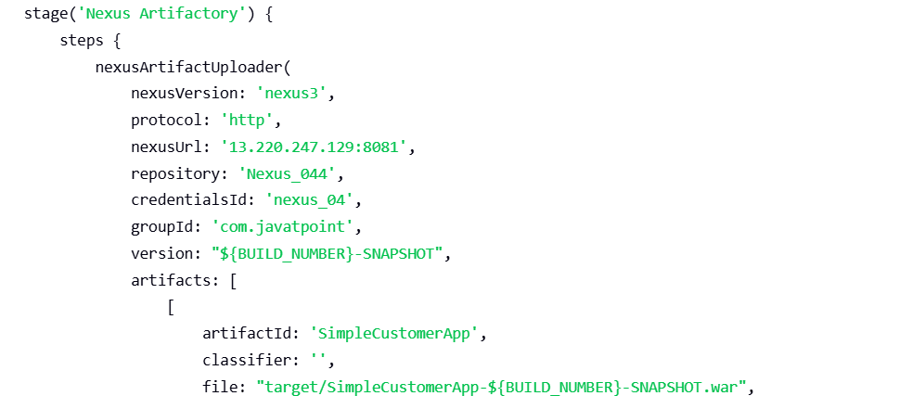
Deploy on Tomcat Stage
Configured Apache Tomcat Manager credentials in Jenkins.
Used Deploy to container (Tomcat 9 adapter).
Tomcat URL used:
http:// 3.223.4.36:8080//
Deployed WAR file from target/*.war.
Application deployed under context path /sabear.
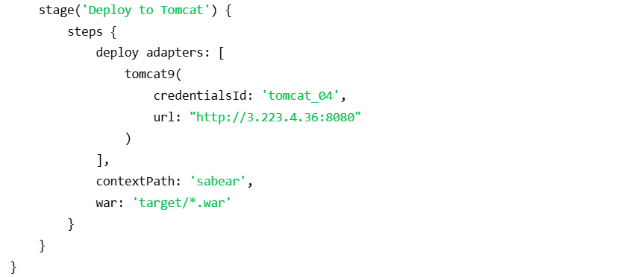

Slack Notification Stage
Configured Slack plugin and Slack token credential in Jenkins.
Used slack Send in post actions.
Notifications sent to Slack channel:
On SUCCESS → Success message with job name and build number.
On FAILURE → Failure message with job name and build number.
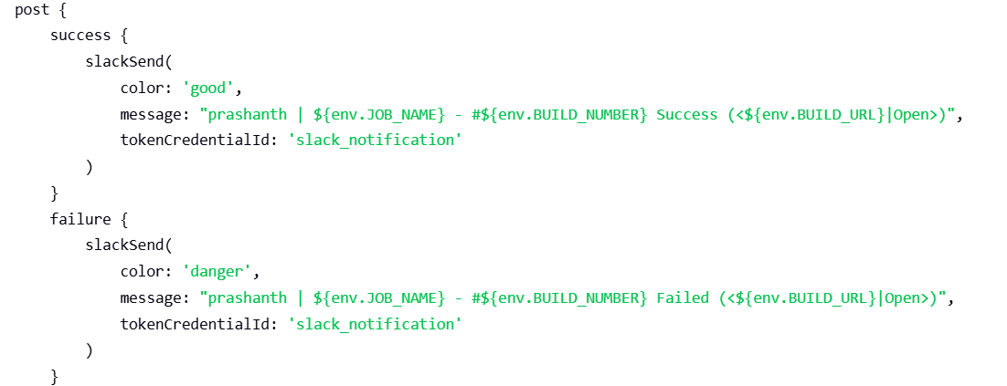
now the pipeline looks as below which has been executed
pipeline {
agent any
tools {
maven 'MVN_HOME'
}
stages {
stage('Git Clone') {
steps {
git branch: 'feature-1.1',
url: 'https://github.com/betawins/sabear_simplecutomerapp.git'
}
}
stage('SonarQube Analysis') {
steps {
withSonarQubeEnv('sonarqube_04') {
sh '''
/opt/sonar-scanner/bin/sonar-scanner \
-Dsonar.projectKey=sabear-simplecustomerapp \
-Dsonar.projectName=SimpleCustomerApp \
-Dsonar.sources=. \
-Dsonar.exclusions=**/*.java
'''
}
}
}
stage('Maven Build') {
steps {
sh '''
mvn clean package
'''
}
}
stage('Nexus Artifactory') {
steps {
nexusArtifactUploader(
nexusVersion: 'nexus3',
protocol: 'http',
nexusUrl: '13.220.247.129:8081',
repository: 'Nexus_044',
credentialsId: 'nexus_04',
groupId: 'com.javatpoint',
version: "${BUILD_NUMBER}-SNAPSHOT",
artifacts: [
[
artifactId: 'SimpleCustomerApp',
classifier: '',
file: "target/SimpleCustomerApp-${BUILD_NUMBER}-SNAPSHOT.war",
type: 'war'
]
]
)
}
}
stage('Deploy to Tomcat') {
steps {
deploy adapters: [
tomcat9(
credentialsId: 'tomcat_04',
url: "http://3.223.4.36:8080"
)
],
contextPath: 'sabear',
war: 'target/*.war'
}
}
}
post {
success {
slackSend(
color: 'good',
message: "prashanth | ${env.JOB_NAME} - #${env.BUILD_NUMBER} Success (<${env.BUILD_URL}|Open>)",
tokenCredentialId: 'slack_notification'
)
}
failure {
slackSend(
color: 'danger',
message: "prashanth | ${env.JOB_NAME} - #${env.BUILD_NUMBER} Failed (<${env.BUILD_URL}|Open>)",
tokenCredentialId: 'slack_notification'
)
}
}
}
click on build now….
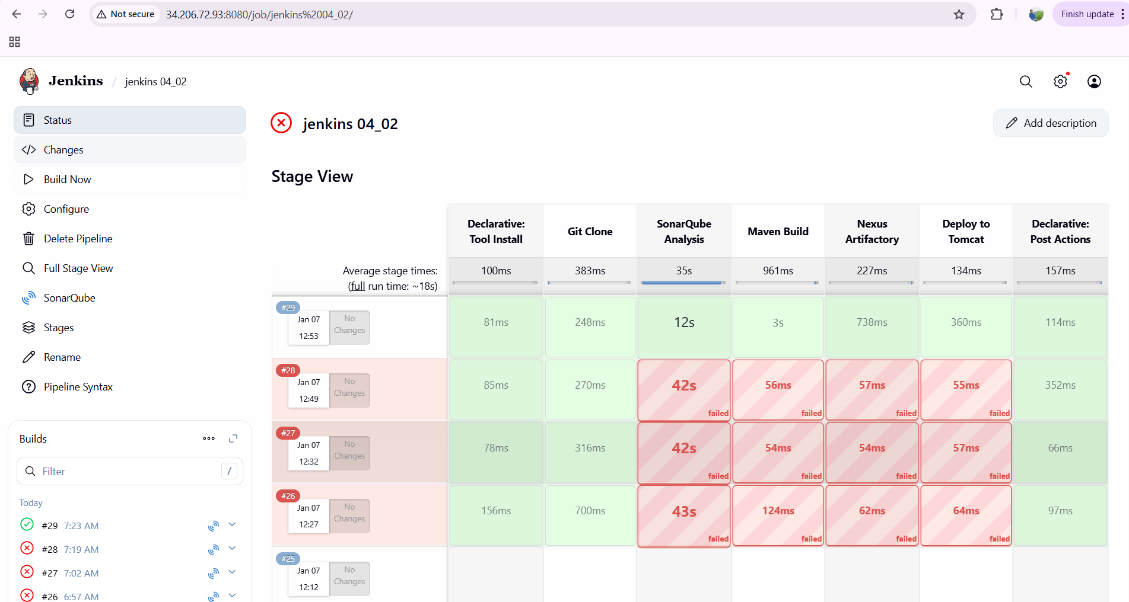
verify in console output:
